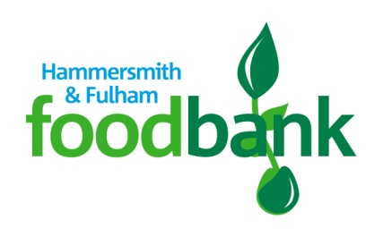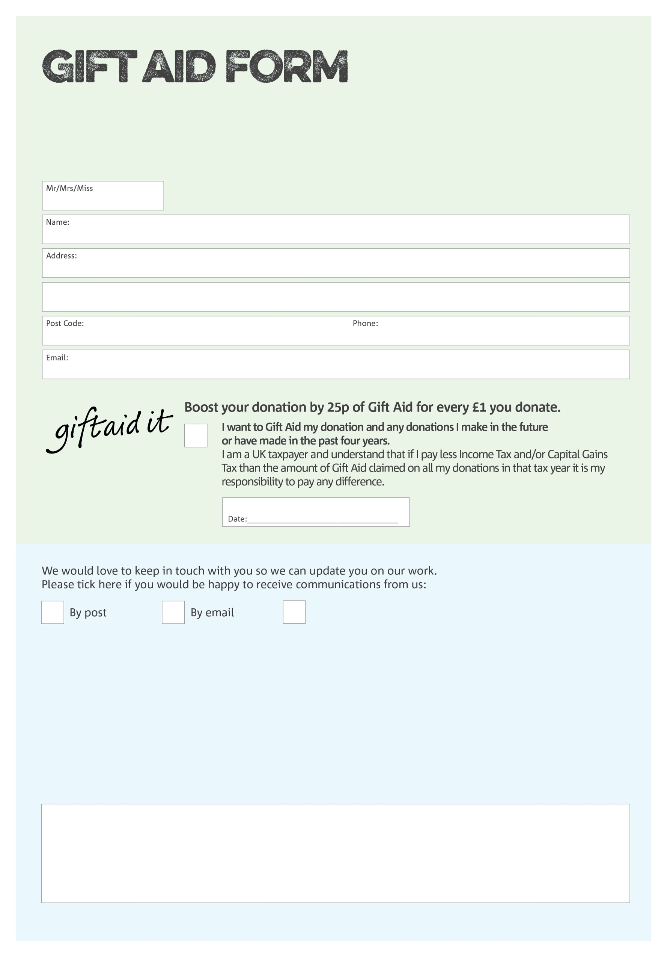

By filling in this form, Hammersmith & Fulham Foodbank will receive an extra 25p for every £1 you give at no extra cost to you. Thank you!

**Data protection**

*Hammersmith & Fulham Foodbank is committed to protecting your privacy and will process your personal data in accordance with current Data Protection legislation. Hammersmith & Fulham Foodbank collects information to keep in touch with you and supply you with information relating to our work. To unsubscribe from our newsletter, send a message to the email address above with the word ‘unsubscribe’ in the subject line. A full data privacy statement for financial donors is available from the foodbank on request.*

You can change your preferences any time by contacting us on 0207 731 3693 or emailing us at

info@hammersmithfulham.foodbank.org.uk

I do not wish to receive future communications from XXXX Foodbank

We would love to know why you have chosen to donate to Hammersmith & Fulham Foodbank. If you would like to share your motivation let us know below:

Registered Charity Number 1148358. Registered in England and Wales.