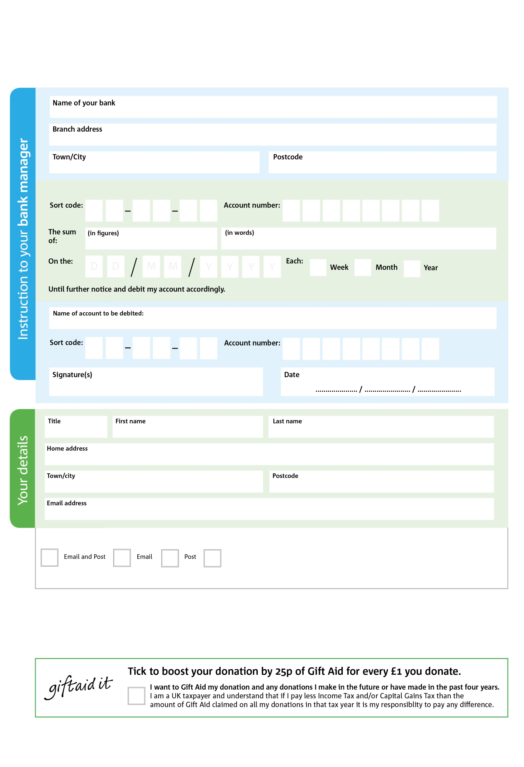

Reg. Charity No: 1148358 | Reg. in England & Wales

Please pay Hamersmith & Fulham Foodbank

**Standing Order Mandate**

**hammersmithfulham.foodbank.org.uk**

POSTAL ADDRESS: Hammersmith & Fulham Foodbank, St Matthews Church, Wandsworth Bridge Road, LONDON, SW6 2TX

0

V

5

V

7

V

9

V

9

V

5

V

5

V

6

V

**Please pass this form onto the foodbank, using the foodbank’s address at the bottom, who will save a copy for their records.   
They will then send it onto your named bank or building society.**

9

9

2

9

8

0

We would love to keep you up to date with information about Hammersmith & Fulham Foodbank. Please tick your preference:

You can change your preferences any time by contacting us on 0207 731 3693 or emailing us at info@hammersmithfulham.foodbank.org.uk

I do not wish to receive future communications from XXXX Foodbank

**Data protection**

*'Hammersmith & Fulham Foodbank is committed to protecting your privacy and will process your personal data in accordance with current Data Protection legislation. Hammersmith & Fulham Foodbank collects information to keep in touch with you and supply you with information relating to our work. To unsubscribe from our newsletter, send a message to the email address above with the word unsubscribe in the subject line. A full data privacy statement for financial donors is available from the foodbank on request.’*

You can change your preferences any time by contacting us on XXXXXXXXXXX or emailing us at XXXX@XXXXXXXXXX.foodbank.org.uk

I do not wish to receive future communications from XXXXXX Foodbank